**Design and Analysis of Algorithm**

**Experiment No. : 5**

**Write a program to implement Strassen’s matrix multiplication**

**Experiment No. 5**

1. **Aim:** Write a program to implement Strassen’s matrix multiplication
2. **Algorithm**

Strassen’s Algorithm is an algorithm for matrix multiplication. It is faster than the naive matrix multiplication algorithm

**Naïve Method**

First, we will discuss naïve method and its complexity. Here, we are calculating ***Z = X × Y***. Using Naïve method, two matrices (***X*** and ***Y***) can be multiplied if the order of these matrices is ***p × q*** and ***q × r***. Following is the algorithm.

**Algorithm: Matrix-Multiplication (X, Y, Z)**

for i = 1 to p do

for j = 1 to r do

Z[i,j] := 0

for k = 1 to q do

Z[i,j] := Z[i,j] + X[i,k] × Y[k,j]

### Complexity

Here, we assume that integer operations take ***O(1)*** time. There are three **for** loops in this algorithm and one is nested in other. Hence, the algorithm takes ***O(n3)*** time to execute.

## Strassen’s Matrix Multiplication Algorithm

Strassen’s Matrix multiplication can be performed only on square matrices where n is a power of 2. Order of both of the matrices are n × n.

Divide X, Y and Z into four (n/2)×(n/2) matrices as represented below –

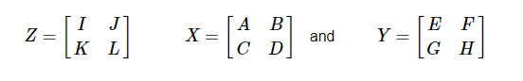

Using Strassen’s Algorithm compute the following –

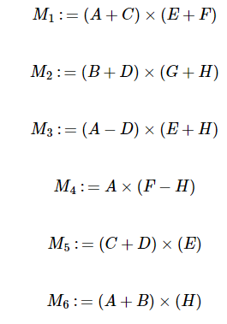

Then

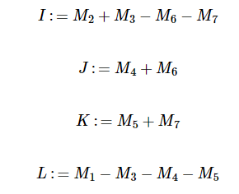

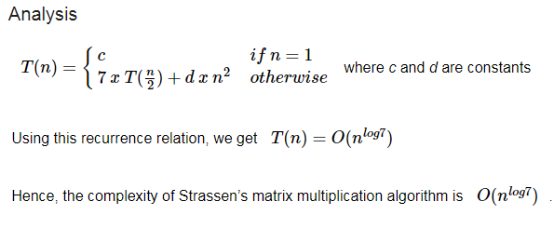

**3. Conclusion and Discussion:** Hence we have **Strassen’s matrix multiplication algorithm**